Задания по английскому языку (группы Сорокиной Н.Н.)
4 В,Г: отвечать на вопросы из списка до 40 вопроса включительно
Учебник стр.42-44 №11 читать, переводить, пересказывать.
Повторять слова по теме «Путешествие»( стр.10№20, стр.18№23 стр. 26 № 25
6Б: учебник стр.82 №2 (слушать текст, читать, переводить, выполнить задание по тексту, написать 10 вопросов по тексту и ответы к ним)
7Б: учебник стр 84 №1,2,3,4 (слушать диск, читать текст, пересказывать, выполнить задания по тексту)
Рабочая тетрадь: стр.46 №1,2,3
8А: учебник стр.93(№1,2,3)
Рабочая тетрадь стр 62 (№ 2,3)
Написать письмо
You have 30 minutes to do this task.
You have received a letter from your English-speaking pen friend, Andrew.
…I’ve decided to take up some sport to be fitter and feel better. But I'm in two minds what to choose. We have a very good basketball team and a super tennis coach…
…What kinds of sports are popular with teenagers in Russia? What sports facilities do you have in your school? What kind of sports competitions do you have at school?…
Write him a letter and answer his 3 questions.
Write 100–120 words. Remember the rules of letter writing
Подготовить устное высказывание по теме
Task 3. You are going to give a talk about your school. You will have to start in 1.5 minutes and speak for not more than 2 minutes (10-12 sentences).
Remember to say:
· what you like most about your school
· what weekday you find the most difficult, and why
· what you would like to change in your school life
You have to talk continuously.
https://www.youtube.com/user/khanacademy (посмотреть видео, пересказать письменно и устно)
повторять песню «Англичанин в Нью Йорке»
11Б подготовить устное высказывание по фото(сравнение)
task 4. Study the two photographs. In 1.5 minutes be ready to compare and contrast the photographs:

·give a brief description (action, location)
·say what the pictures have in common
·say in what way the pictures are different
·say which kind of life you’d prefer
·explain why

You will speak for not more than 2 minutes. You have to talk continuously.

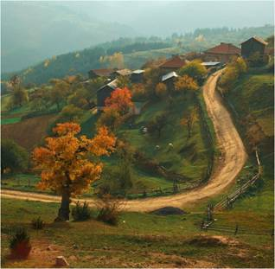

http://www.bbc.com/travel/story/20180704-the-curious-story-of-denmarks-rebel-cakes

прочитать статью, написать краткое содержание своими словами)
Написать эссе
Comment on the following statement.
It is the government’s responsibility to protect the environment.
What is your opinion? Do you agree with this statement?
Write 200–250 words.
Use the following plan:
– make an introduction (state the problem)
– express your personal opinion and give 2–3 reasons for your opinion
– express an opposing opinion and give 1–2 reasons for this opposing opinion
– explain why you don’t agree with the opposing opinion
– make a conclusion restating your position

